**Queries in MongoDB:**

1. **Find average price of all products**

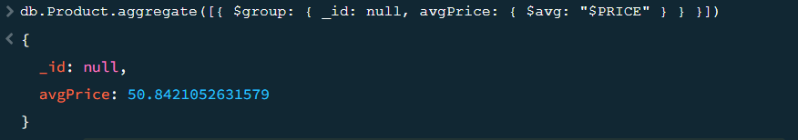

1. **Update the status from false to true of an order having Order ID: 2**

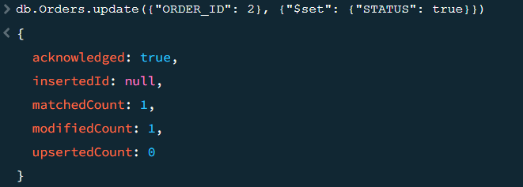

1. **Count the total number of queries (FEEDBACK THEY SEND TO ADMIN) for each employee**

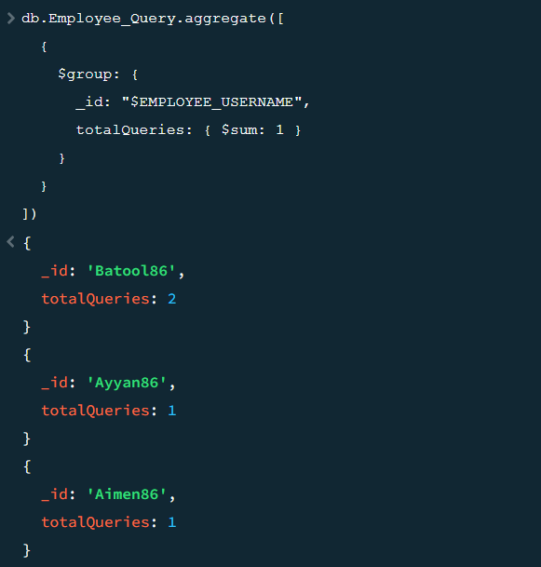

1. **Count the total number of products in each category**

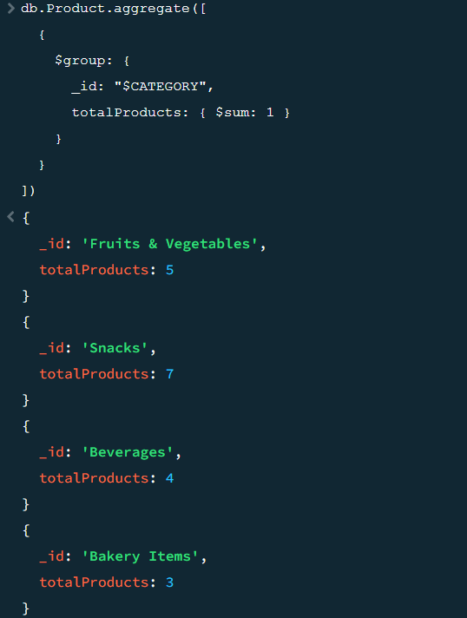

1. **Count the total price of Stock of each Category Item**

